Energy Meter Theory: https://www.digikey.com/en/articles/the-basics-of-current-sensors
Current Sensor Exact: ACS773ECB-200B-PFF-T
Mating Housing: page 9 of datasheet

5 segments
Current sensor 3 pole voltage - which one
Bit bumping to fill the byte - 5 sensors across 32 bits?
Adc vs using adc on esp32
Program the adc?
Should i filter the input to adc
What protocol is one wire - serial without a clk?????? - BIT BANGING
Precision necessary for adc to be separate?
Parasitic power

Constraints:
- Integrate energy meter with mating device (requires cutting and extrusion)
- Energy meter in series with TS path
  - Depending on current sensor it will be over CAN or analog
- ESP32 to read current sensor output
- Autotransformer to step down 12 V to 6.5 V
- Include connector to pull data from
- Needs to be logged
  - Turn off tractive system, keep GLV on and pull data from PCB - isolated from rest of car
- Cf and Rf for filtering on Vout
- Cbyp for Vcc filtering

Requirements:
- 3 TS connections:
  - 2: wired in series with tractive system for current sensor
    - Cant be wired mid pack
  - 1: wired to other pole for sensing voltage
- Must be TRACTIVE SYSTEM SIDE OF ISOLATION RELAYS
- 7 GLV connections:
  - 1 - temp sense gnd for HV
  - 2 - temp sense one wire
  - 3 - no connection
  - 4 - CAN L
  - 5 - CAN H
  - 6 - GLV -
  - 7 - GLV +
- Energy meter requirements
  - Current draw: 125 mA
  - CAN rate 500k
  - Access real time energy meter data over CAN
  - Can log various vehicle info to energy meter over CAN (conveinence)
  - ALL CAN IS OPTIONAL
  - CAN IS BIG ENDIAN

Includes terminating resistor

- ENERGY METER TRANSMITTED MESAGES
  - 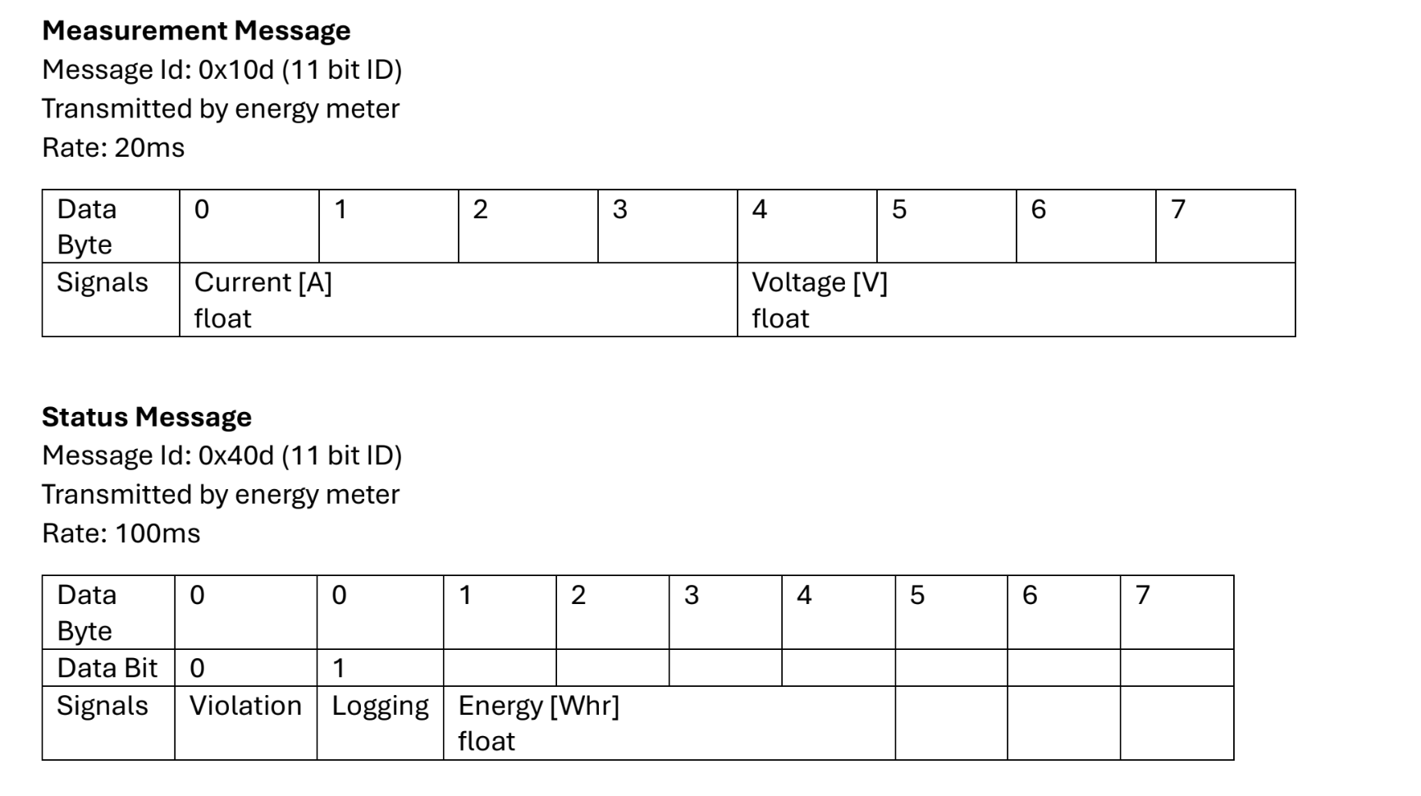

- 1 energy meter temp sensor PER SEGMENT
  - IN HOTTEST SECTION

INTERFACING LOGISTICS:
- GLV power and energy meter boot
- Begin logging when TS > 60 V
- Stop logging when TS < 60 V
- LED indicators:
  - 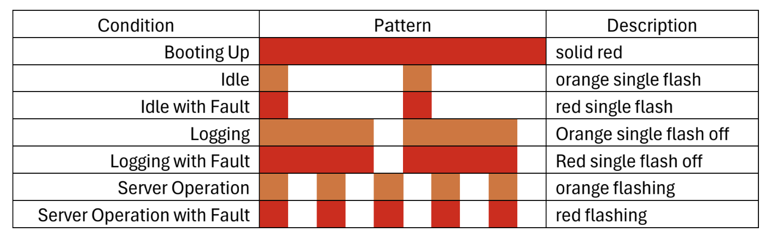

DOWNLOADING DATA
- Download cable will supply power, not GLV

